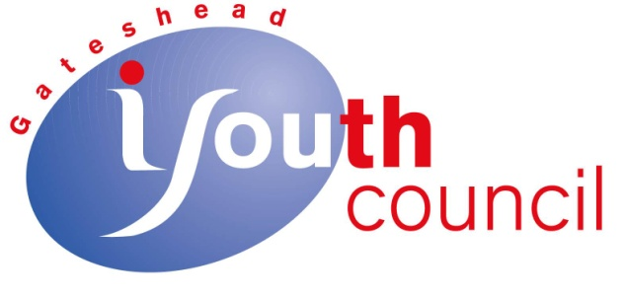

Gateshead Youth Council
Financial Statement
1st January 2016 – 31st December 2016

Balance at 1st January 2016 £ 17934.39
Income £ 12727.09
Expenditure £ 9902.68
Balance at 31st December 2016 £ 20758.80

Income Expenditure
Grants £ 8750.00 Rent £ 4765.00
The Key £ 250.00 Services £ 265.27
Donations &memberships £ 550.00 Activities/Events £ 3456.06
Sales & Commissions £ 2900.00 Equip/Postage/Misc £ 476.80
Other £ 277.09 Restricted £ 177.80
Membership Fees £ 211.50
Insurance & Fees £ 439.25
Bank charges £ 111.00

TOTAL £12727.09 £ 9902.68

